**ICEBERG User manual**

**Sales Module**

**Last updated: 06/08/2018**

**SALES MODULE:**



**As of now in ICEBERG application totally, we have Eight roles**

1. **Business development manager (**ROLE_BDM) **(**
2. **ICE director (**ROLE_ICEDIRECTOR)
3. **Delivery manager (**ROLE_DELIVERY)
4. **Operation team (**ROLE_OPERATION)
5. **Legal Team (**ROLE_LEGAL)
6. **Content manager (**ROLE_CONTENT)
7. **Program manager (**ROLE_PROGMANGR)
8. **Operation Lead (**ROLE_OPERATIONLEAD)

**Landing page**

* To access the Iceberg application Please click on the URL:

This is the landing page of the Iceberg application



**Login Screen**

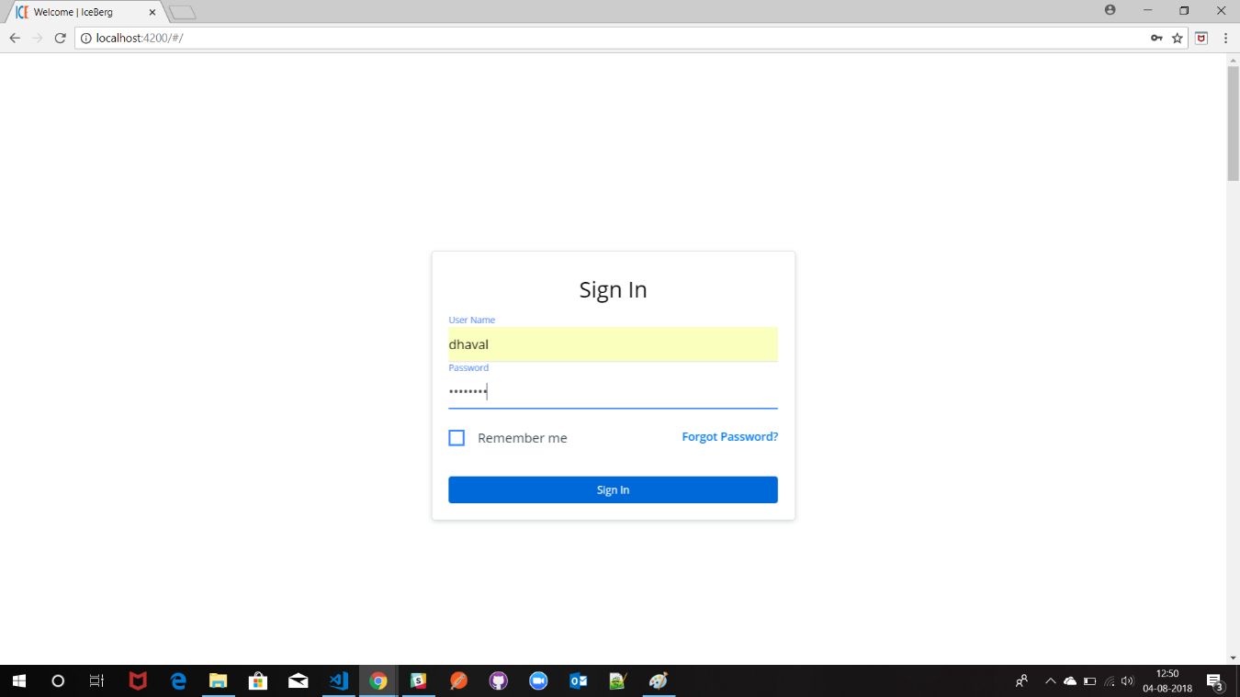

Now we will Sign in as ROLE_BDM

The dashboard of BDM along with Todo list

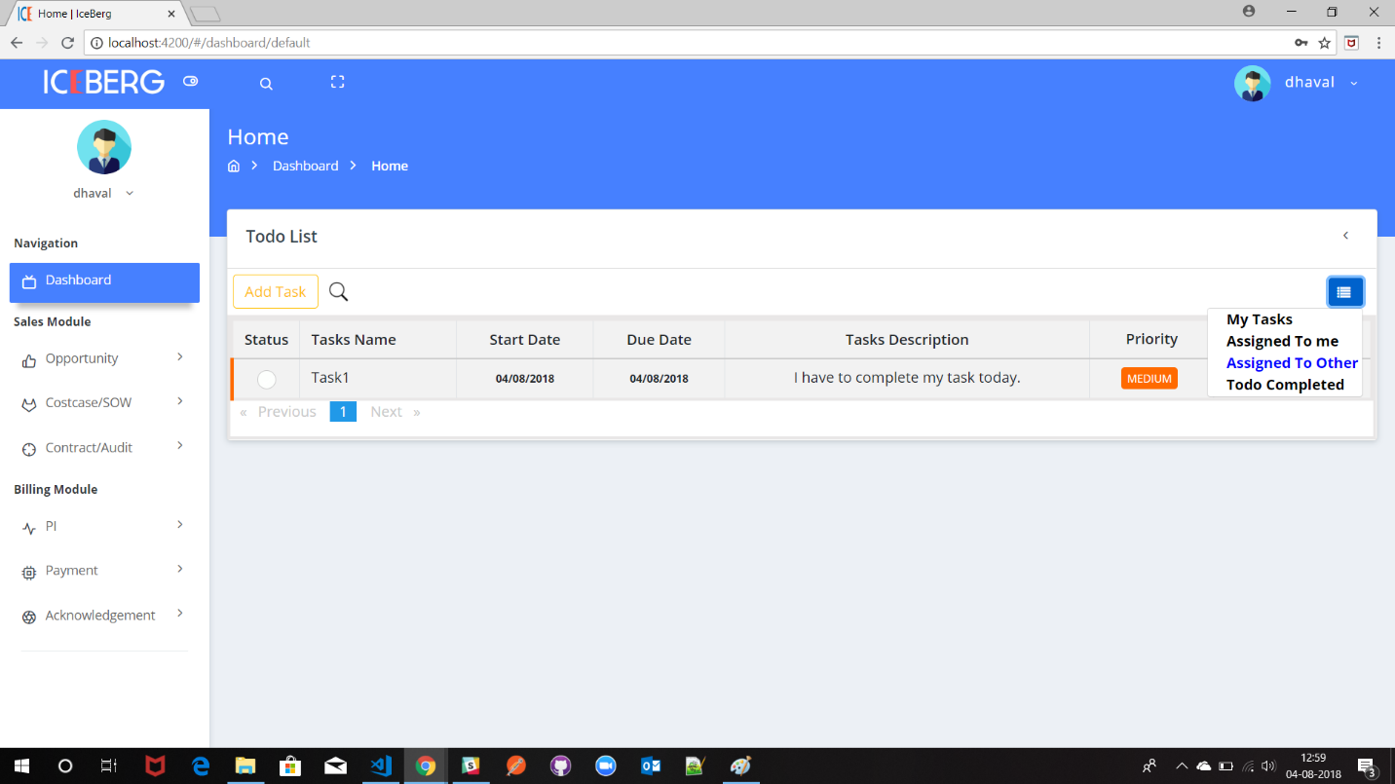

1. **Creation of Opportunity**

Click on **Opportunity** tab in the sidebar after that click on **Add opportunity** now you should see Lead tracker sheet

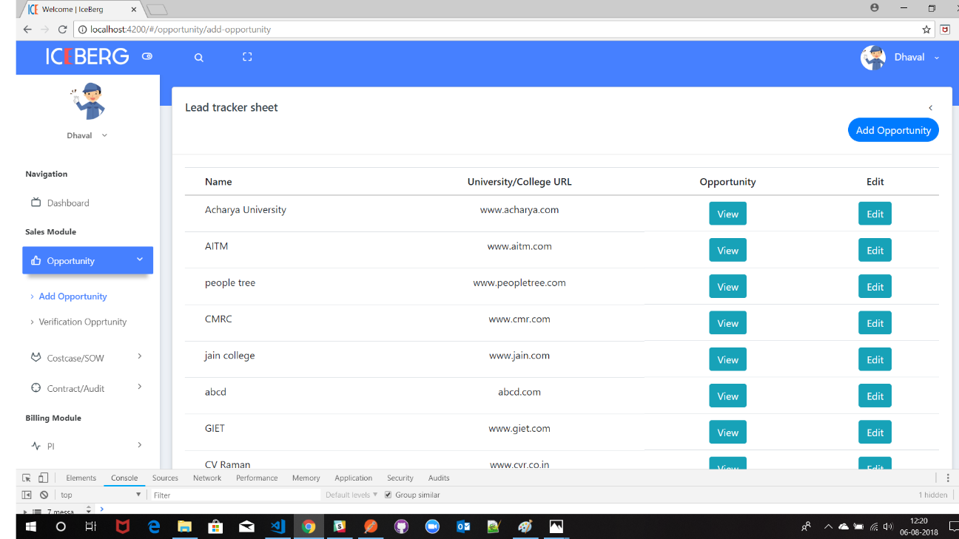

To add the opportunity, Click on **Add opportunity** button on the top left side of the Lead tracker sheet table.

After clicking on the Add opportunity you should be able to see a pop-up like below image.

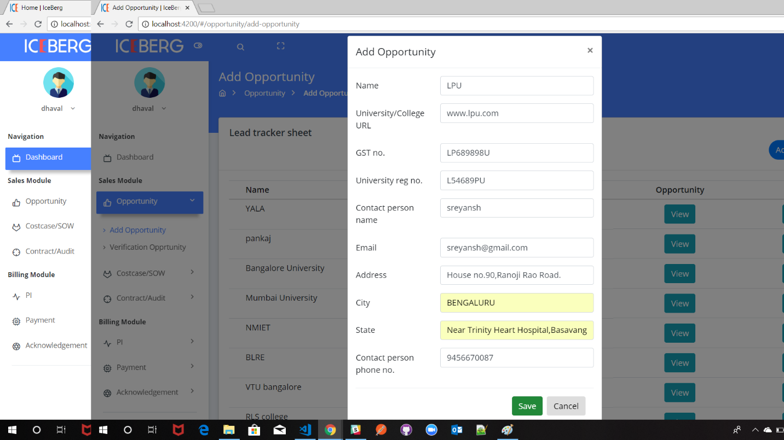

Fill all the required details and click on Save button to save the opportunity.

After you add the opportunity you can see the opportunity details in the lead tracker sheet table.

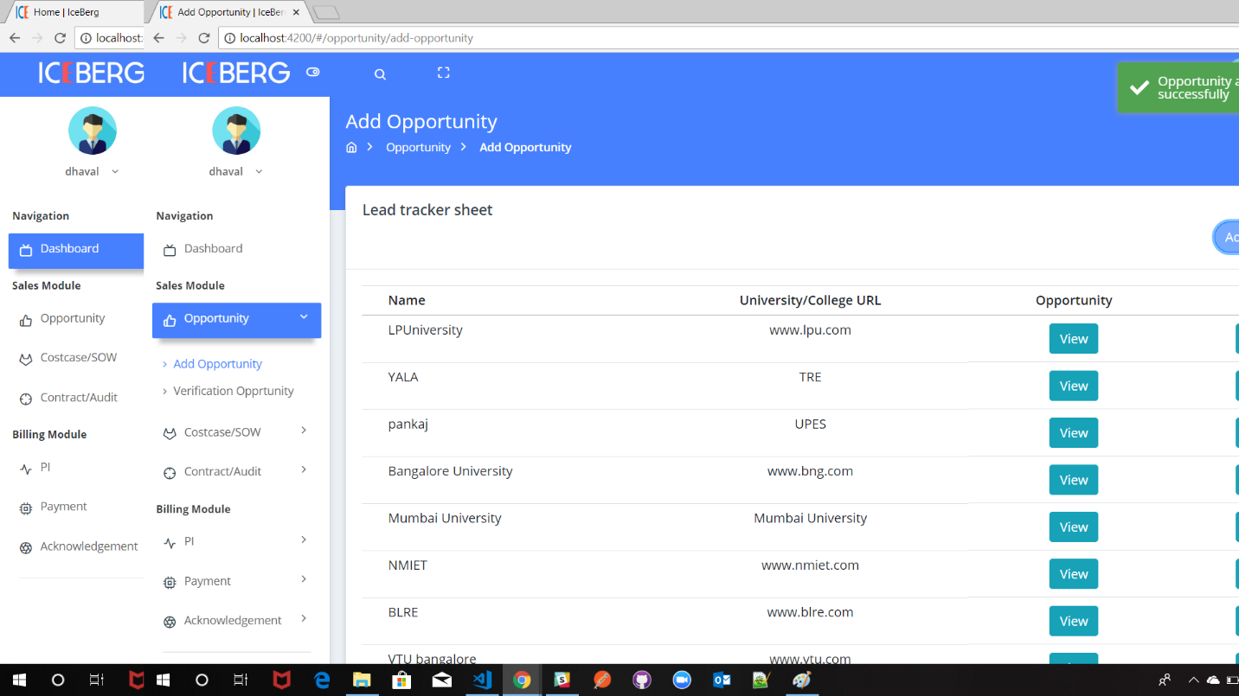

1. **Verification of Opportunity**

After the opportunity is added to the Lead tracker Sheet it must be verified by three Process

1. DPL
2. ERO
3. CSEG

TO verify the Opportunity, click on the **Verification opportunity** button on the sidebar

After you click on that button you can see the List of opportunity along with their status.

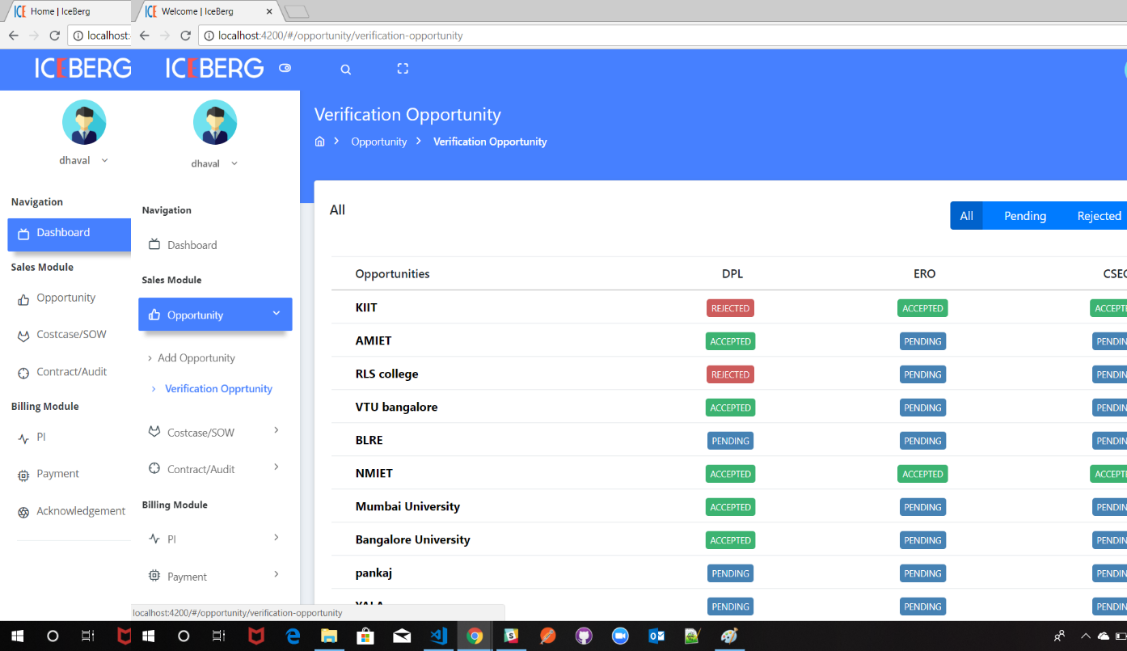

To change the status of verification opportunity, Click on the **Opportunity name.**

In the below image provide the option to change the status on opportunity and upload the file

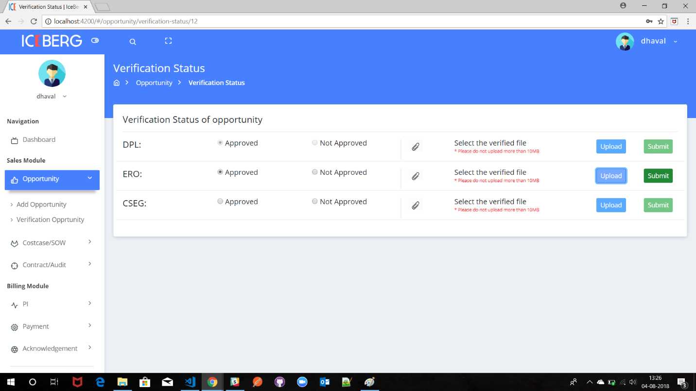

**Note:**

If we want to change the status of **ERO,** customer number should be uploaded by the operation team.

1. **Upload the customer number**

**To upload the customer number Login as operation team**

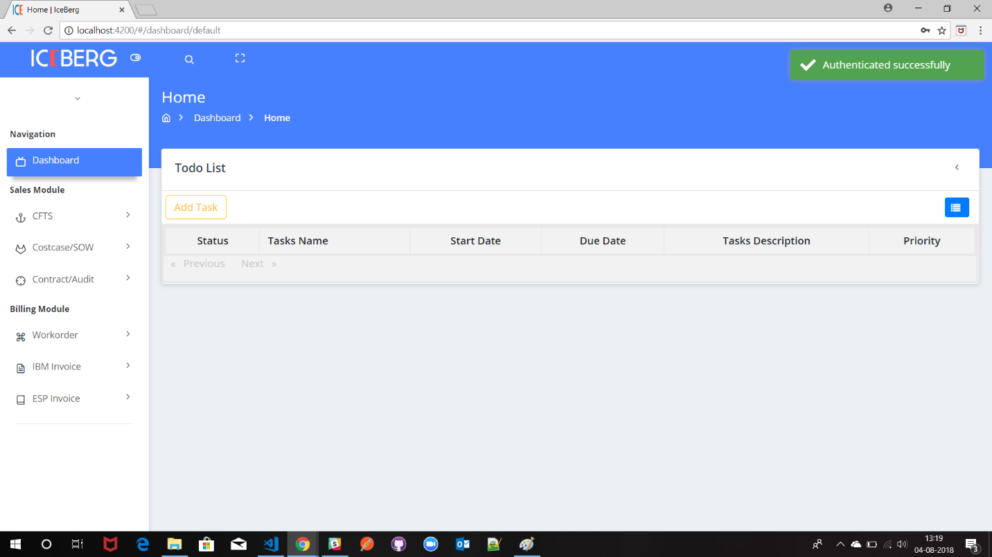

Now Click on **CFTS** on side bar > click on **Add customer number** button. Then there will be pop-up like below image.

At the end of the pop-up there will be option to update the customer number

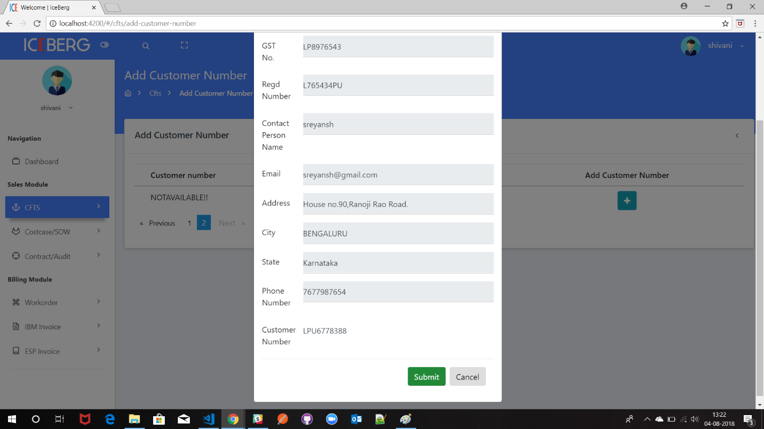

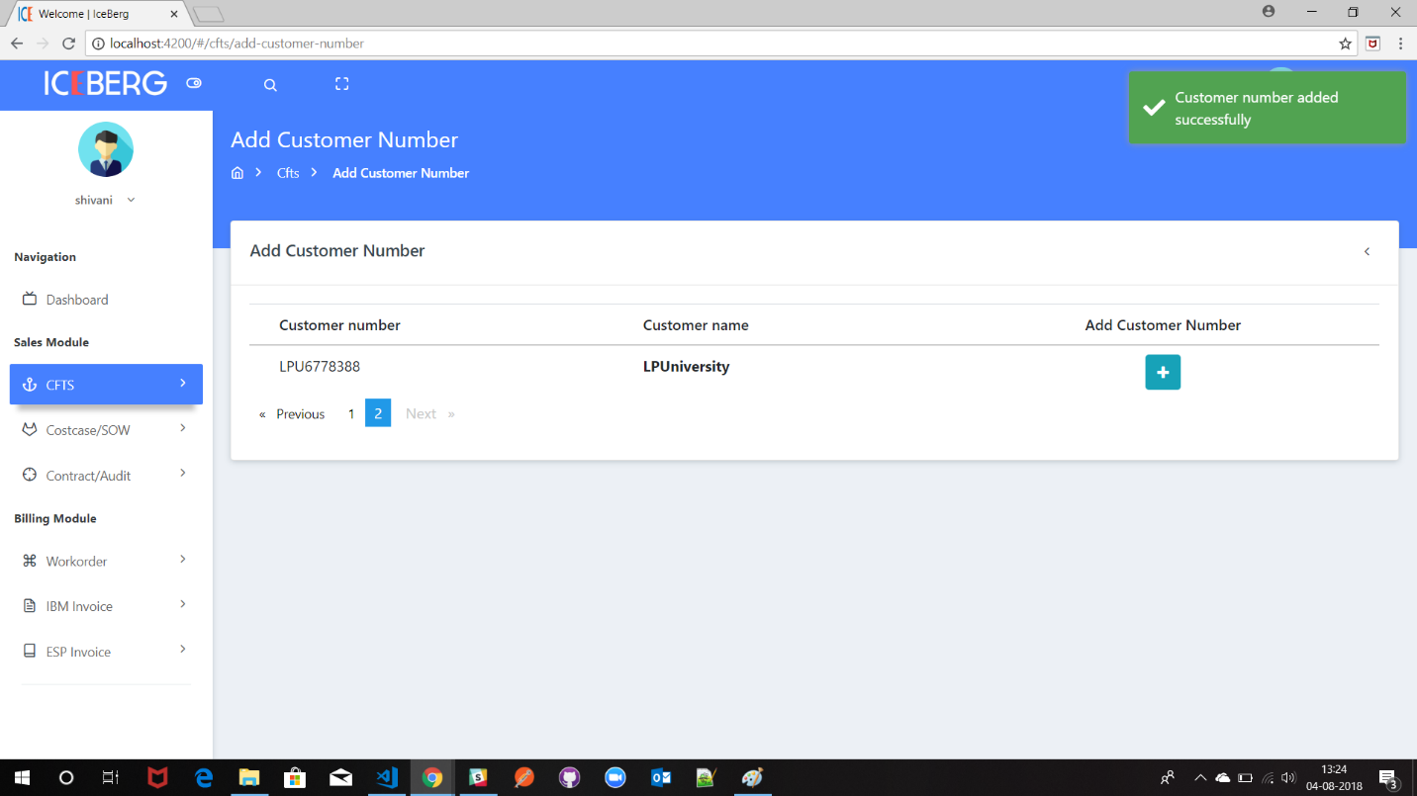

After adding the customer now, you can update the Status of the ERO and CSEG for the Verification opportunity.

1. **Creation and verification of Cost case of Opportunity**



To create the Cost case, click on the sidebar **Cost case/sow > cost case**

In this page there will list opportunities

Now click on create cost case button

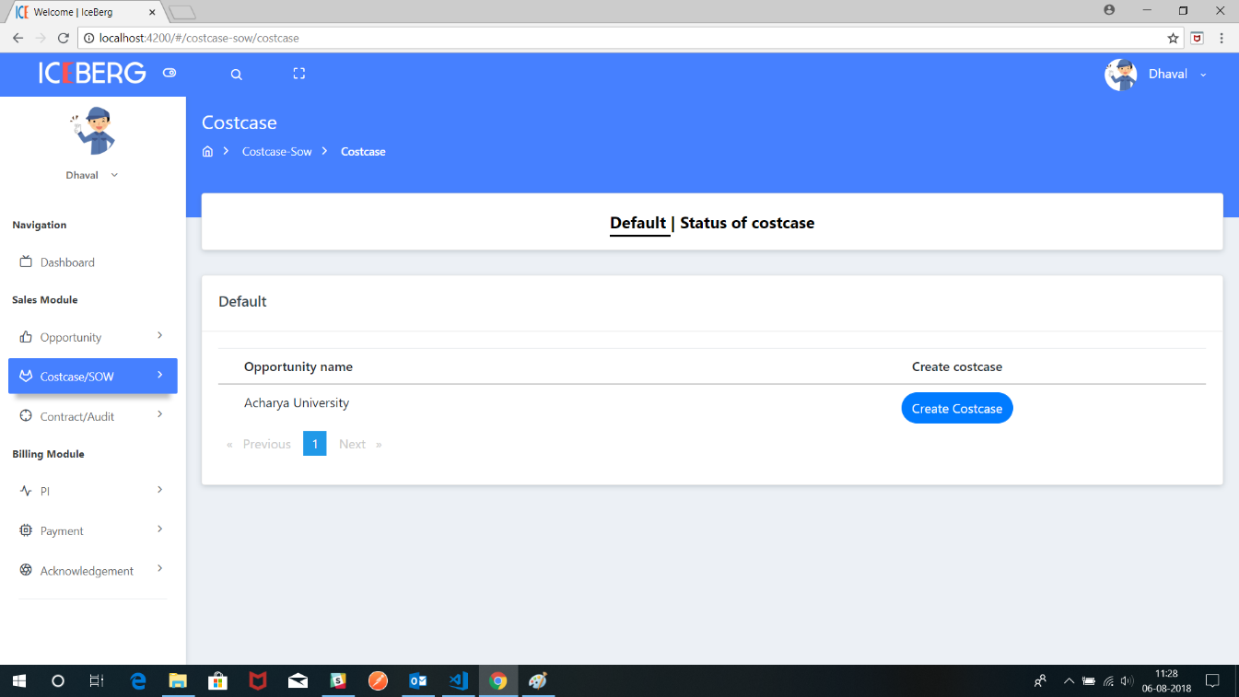

After that upload the cost case attachment and write the description then send it to operation team for the approval.

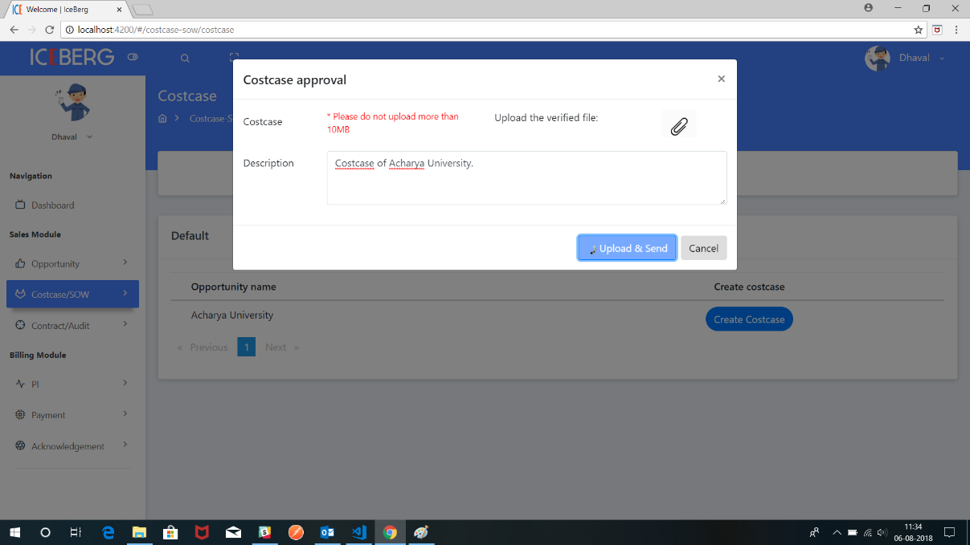

Now the operation team will get the cost case with attachment and description.

After login as **operation team click** on the sidebar **costcase/sow > costcase of operation team**

In the below screen click on the view button so that you can download file and view the description of that costcase.

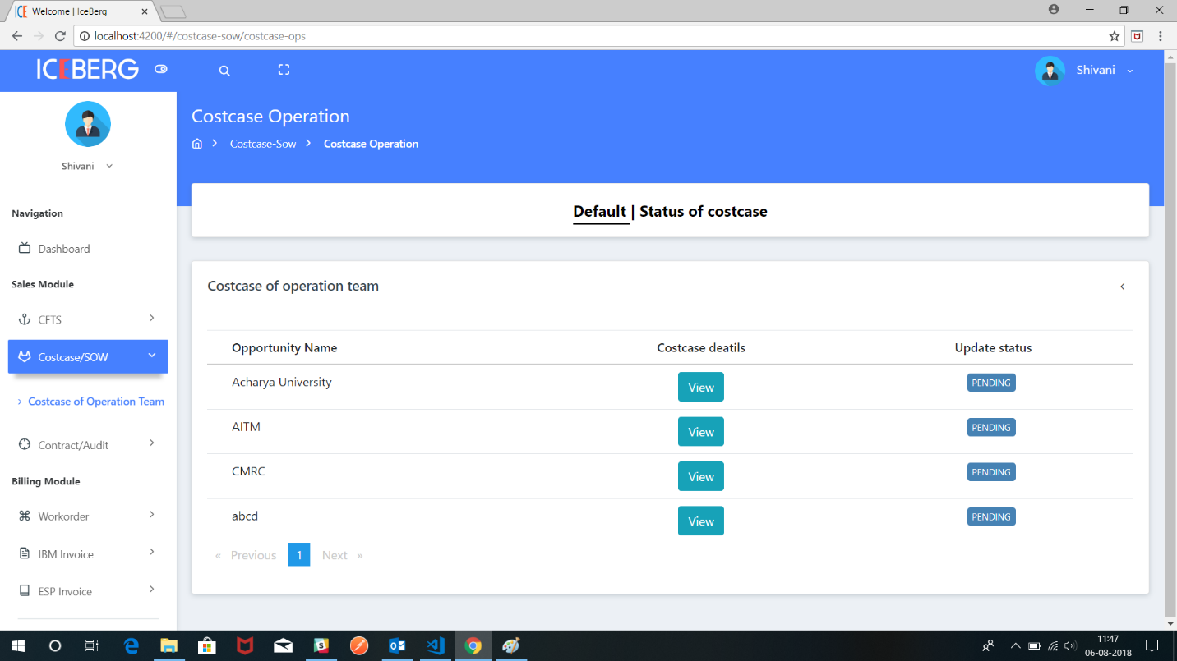

To change the status please click here

To change the status of the cost case, click on the pending

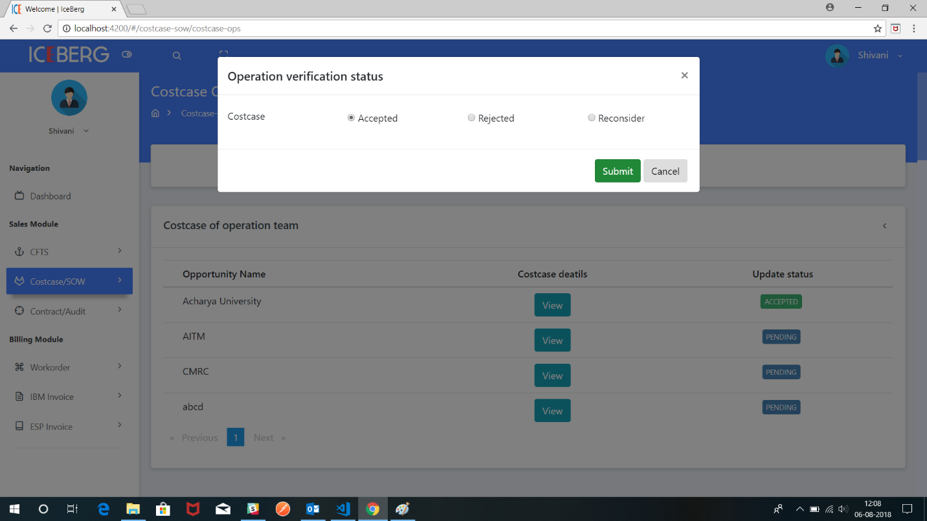

If Cost case is accepted by the Operation team it will be sent to delivery team

If cost case is rejected by operation team it will be sent back to BDM

If cost case is reconsider it will sent back to BDM with reconsider attachment.

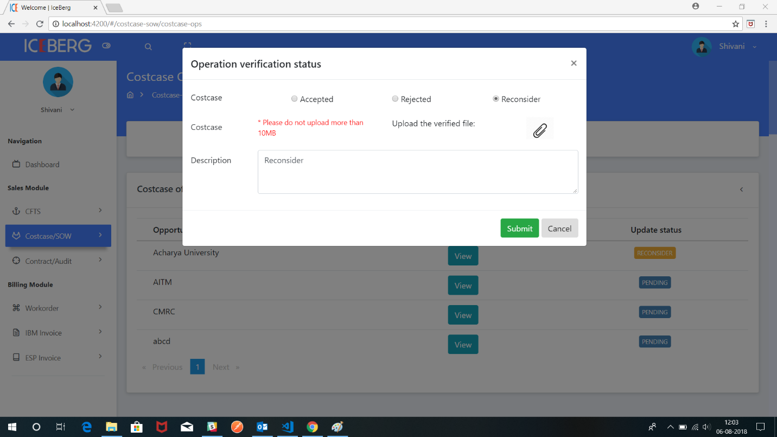

For BDM to check the status of the cost case click on the status of the cost case button

To view the reconsider cost case, click on the reconsider button you can see list of reconsider cost case

Now click on the view button to see what cost case has been sent from operation team

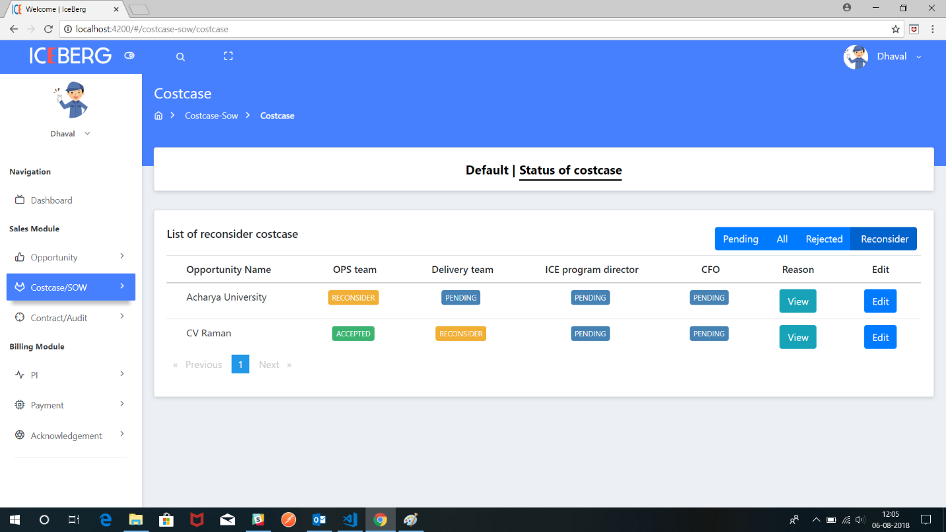

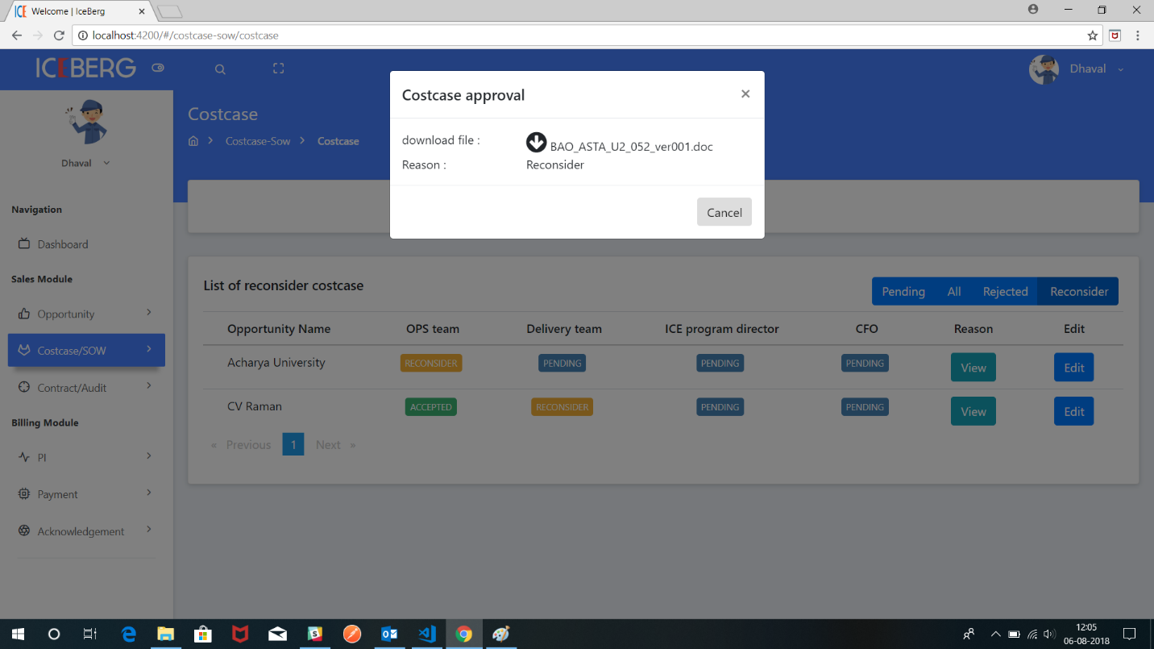

BDM can download reconsider attachment

Now BDM should click on edit button and upload the new attachment along with description sent back to operation team.

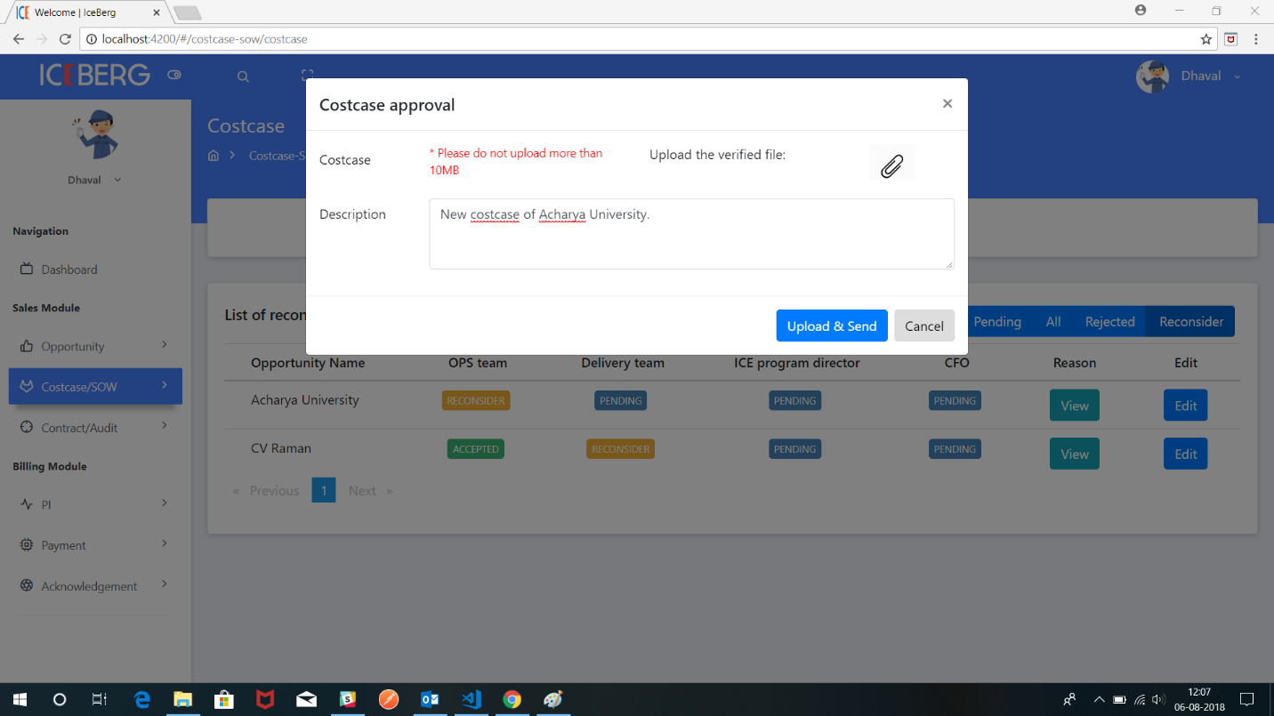

This process continues same for delivery, Ice director and CFO

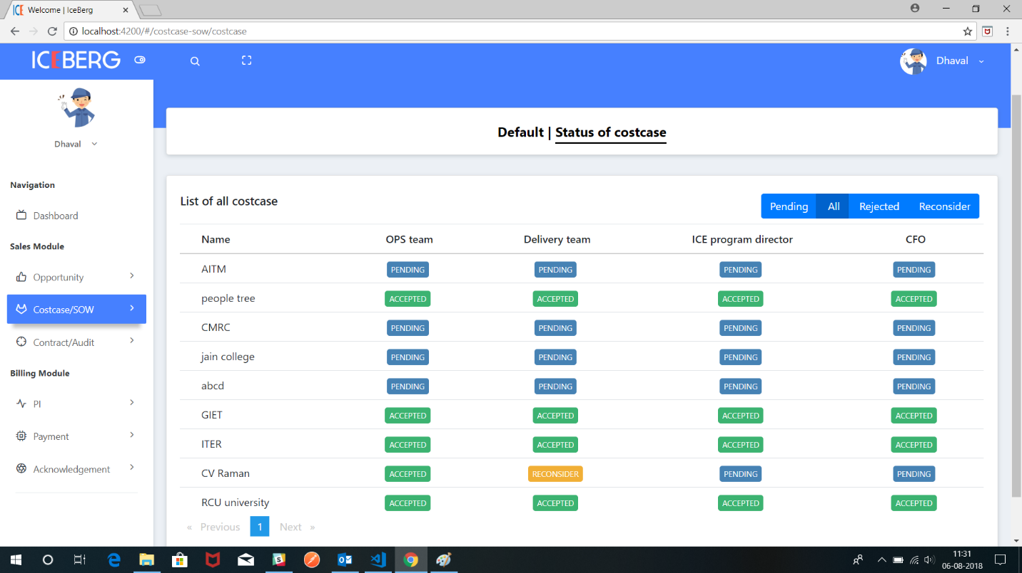

1. **Creation of SOW**



The above diagram will show flow of **SOW** across all the users.

**BDM** will create the SOW (statement of work) send it for Legal team, delivery team and ice director.

To create the SOW click on Create SOW button and upload the file and write the description about and send it to legal team for approval.

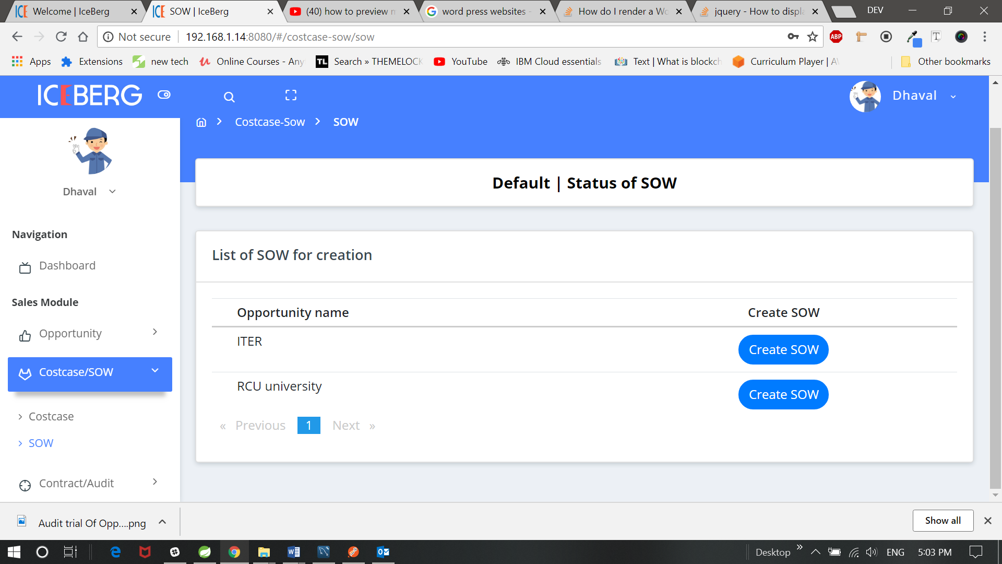

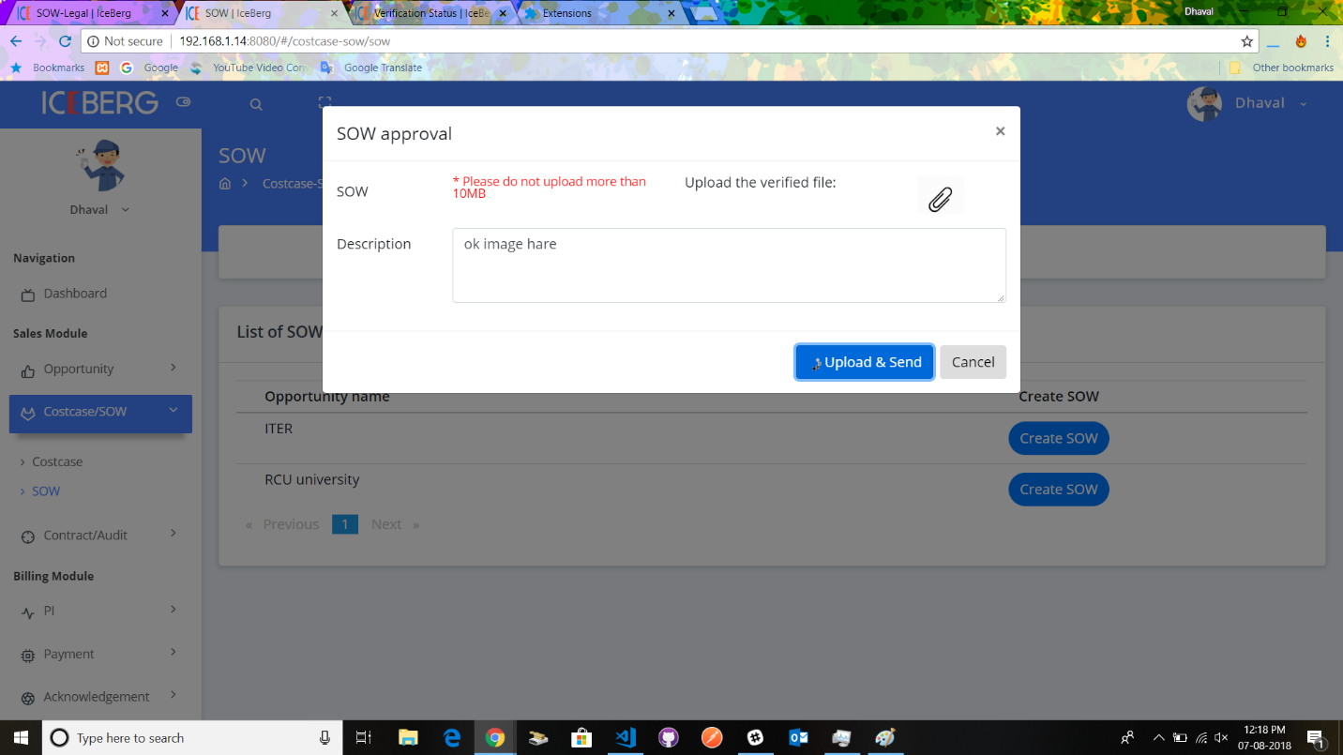

After it has sent from BDM it will reach the Legal team now legal team have to SOW pending list for Approval.

If Legal Team say Accepted then SOW will sent for Delivery team

If Legal Team say Rejected then SOW will sent back to BDM

If Legal team click on reconsider then SOW attachment with reconsider reason will go back for BDM.

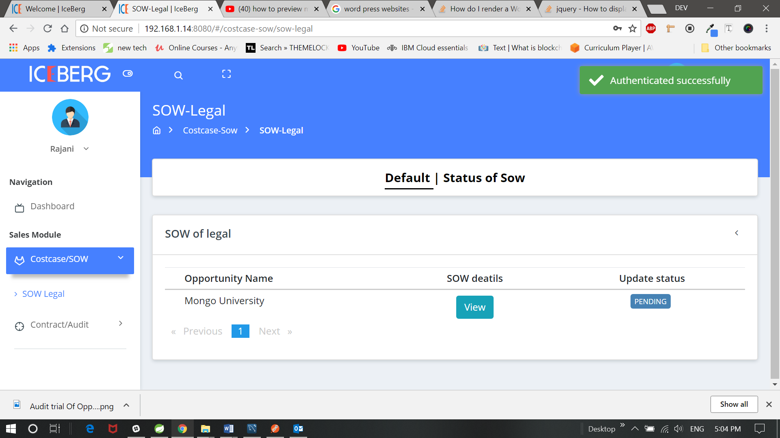

If legal team click on rejected and should write the description and send it back to BDM

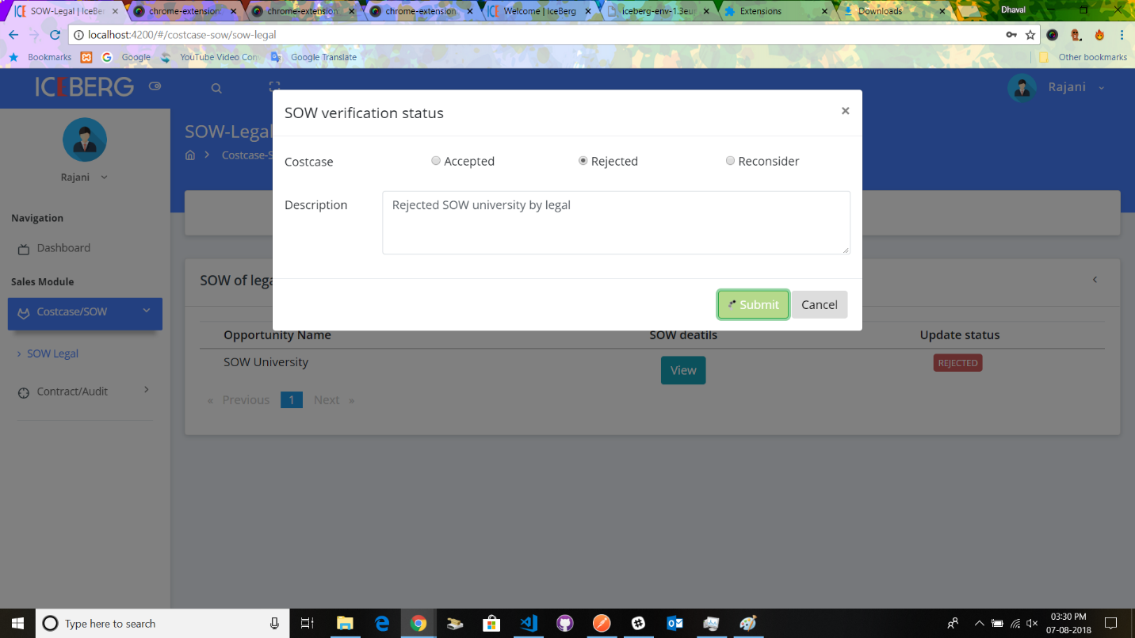

Now if legal team click on reconsider they should add the attachment along with the description and click on submit button.

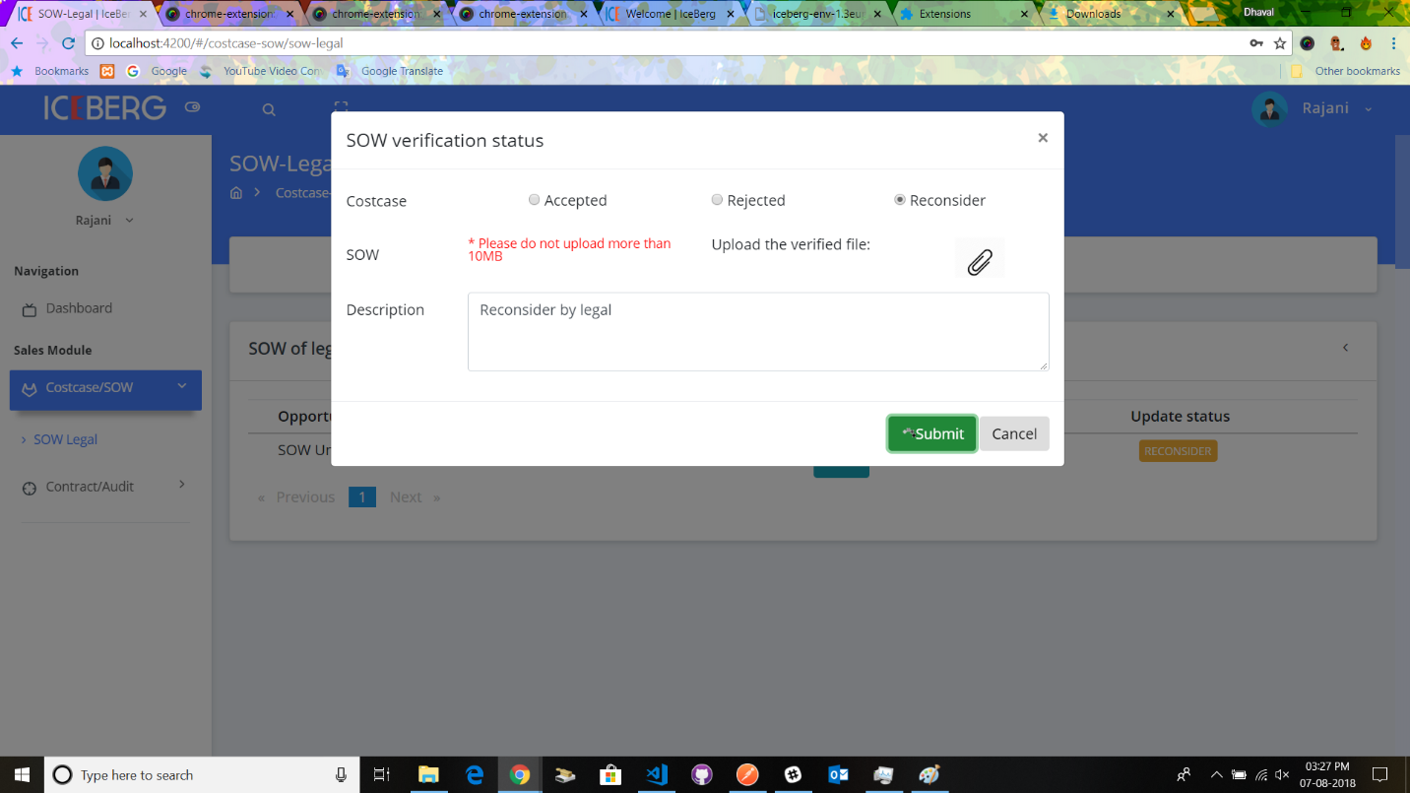

1. **Contract sign-in process**

After all the cost case and sow is prepared and accepted by all the team, contract details has to be saved.

To save the contract details Click on **contract/audit > contract signing**

Now you can see list of opportunities, click on **Create contract button**

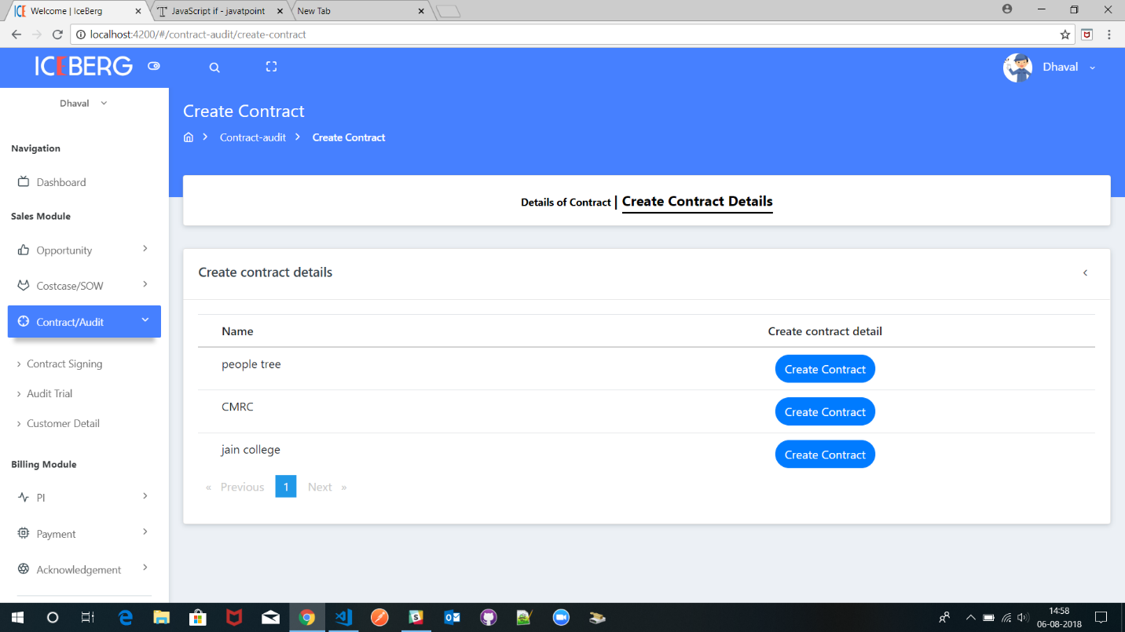

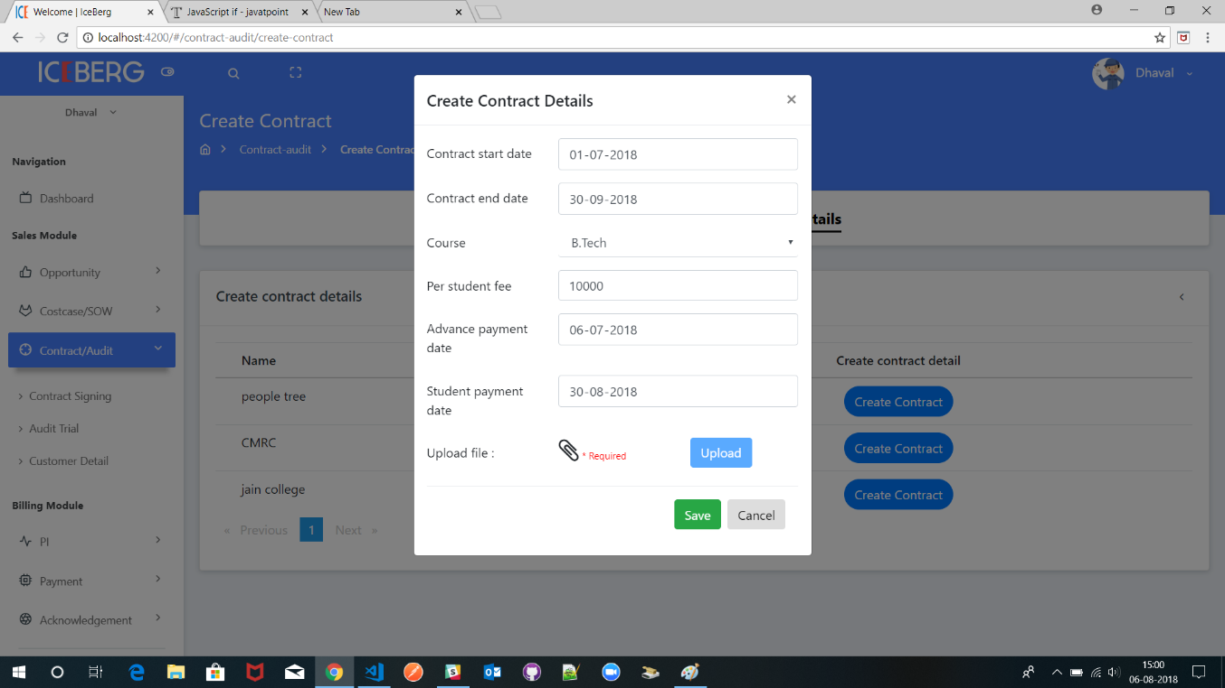

Fill up all the required details and insert the signed contract attachment now click on upload button then click on save button.

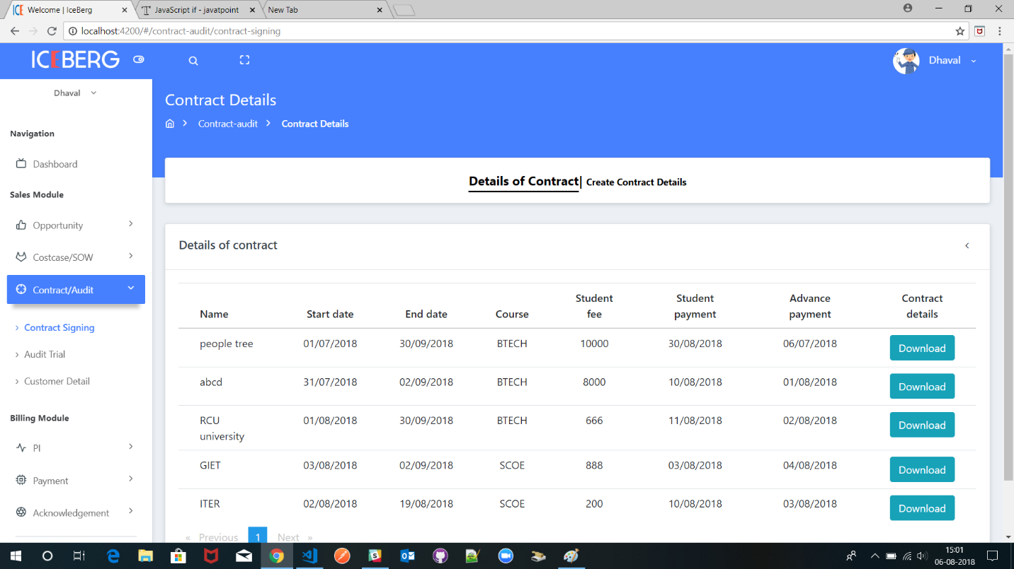

Above image displays list of contracts already registered.

1. **CFTS Check list**

**The below image displays list of CFTS for the opportunity**

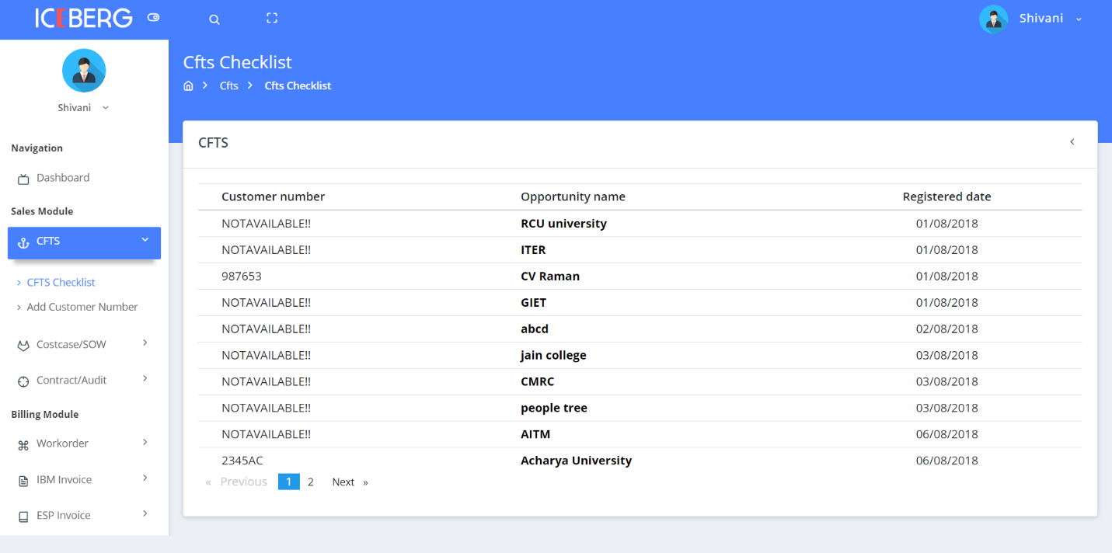

Click on the **opportunity name** to see full details of opportunity along with attachments for CFTS registration.

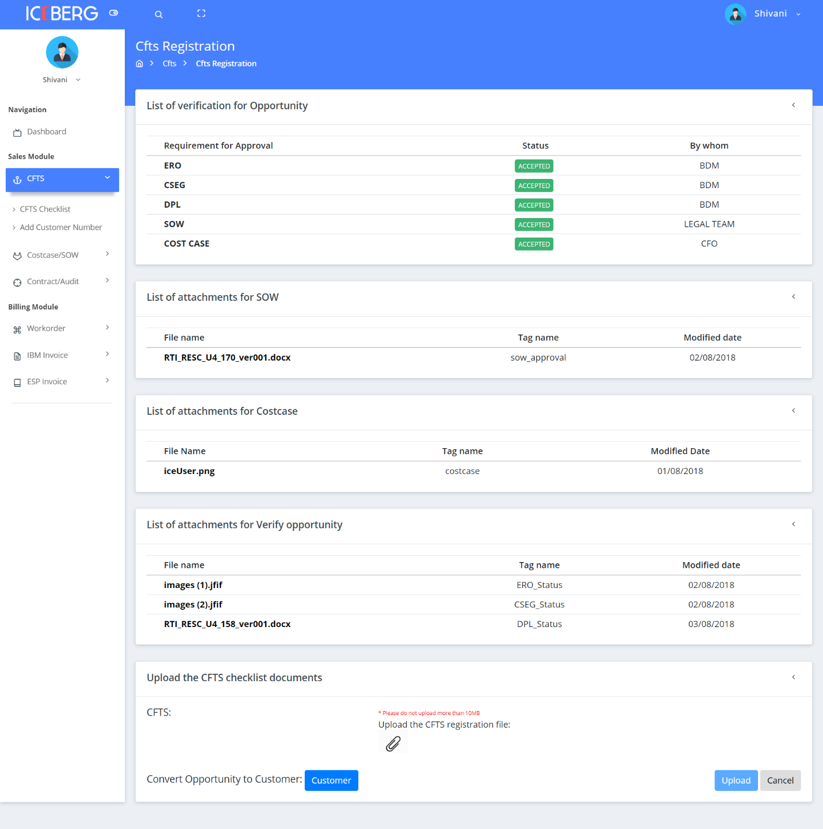

1. **Audit trial**

Audit trial gives the brief overview the opportunity from

Click on the **Audit trial** on the sidebar to navigate to that page.

Click on the Opportunity name to see the full detail view of opportunity.

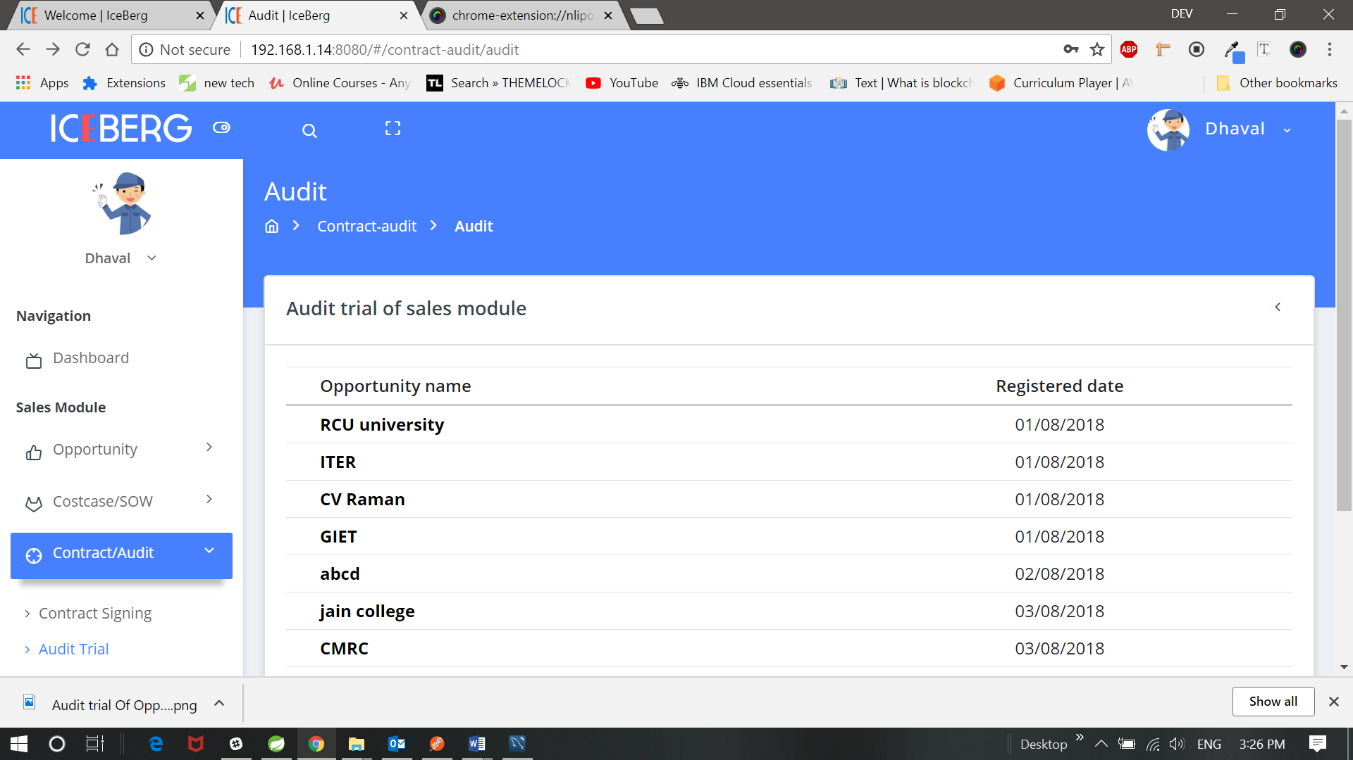

* The below image displays brief overview of opportunity from Verification of opportunity to SOW approval.

